|  |
| --- |
| Microsoft SharePoint 2013 - Hands-on Lab |
| Search |
| Verified Against Build 15.0.4420.1017 |

|  |
| --- |
| Microsoft  Version 1.0  August 14, 2012 |

Information in this document, including URL and other Internet Web site references, is subject to change without notice. Unless otherwise noted, the example companies, organizations, products, domain names, e-mail addresses, logos, people, places, and events depicted herein are fictitious, and no association with any real company, organization, product, domain name, e-mail address, logo, person, place, or event is intended or should be inferred. Complying with all applicable copyright laws is the responsibility of the user. Without limiting the rights under copyright, no part of this document may be reproduced, stored in or introduced into a retrieval system, or transmitted in any form or by any means (electronic, mechanical, photocopying, recording, or otherwise), or for any purpose, without the express written permission of Microsoft Corporation.

The names of manufacturers, products, or URLs are provided for informational purposes only and Microsoft makes no representations and warranties, either expressed, implied, or statutory, regarding these manufacturers or the use of the products with any Microsoft technologies. The inclusion of a manufacturer or product does not imply endorsement of Microsoft of the manufacturer or product. Links are provided to third party sites. Such sites are not under the control of Microsoft and Microsoft is not responsible for the contents of any linked site or any link contained in a linked site, or any changes or updates to such sites. Microsoft is not responsible for webcasting or any other form of transmission received from any linked site. Microsoft is providing these links to you only as a convenience, and the inclusion of any link does not imply endorsement of Microsoft of the site or the products contained therein.

Microsoft may have patents, patent applications, trademarks, copyrights, or other intellectual property rights covering subject matter in this document. Except as expressly provided in any written license agreement from Microsoft, the furnishing of this document does not give you any license to these patents, trademarks, copyrights, or other intellectual property.

Copyright © 2012 Microsoft Corporation. All rights reserved.

Microsoft and SharePoint are either registered trademarks or trademarks of Microsoft Corporation in the United States and/or other countries.

The names of actual companies and products mentioned herein may be the trademarks of their respective owners.

# Introduction

## Estimated time to complete this lab

60 minutes

## Objectives

After completing this lab, you will be able to:

* Customize the query pipeline
* Customize the display of search results
* Write RESTful search queries

## Overview of Lab

This lab will walk you through the major components of SharePoint search. You will create result sources, query rules, and result types to build a search vertical with no code. Then you will create a SharePoint App that makes RESTful queries against the search service.

## Virtual Machine Technology

The computers in this lab are virtual machines that are implemented using Microsoft Hyper-V. Before starting each virtual machine, ensure you apply the **Start-Lab** snapshot. When you have started a virtual machine, log on by pressing **CTRL+ALT+END** and supply the credentials listed in the lab instructions.

## Computers in this lab

This lab uses virtual machines as described in the following table. Before you begin the lab, you must start the virtual machines and then log on to the computers.

|  |  |
| --- | --- |
| **Virtual Machine** | **Role** |
| {Supplied by Instructor} | Domain Controller |
| {Supplied by Instructor} | Actual SharePoint environment with Office client and other required software. |

All user accounts in this lab use the password {Supplied by Instructor}.

# Exercise 1: Creating and Crawling the Glossary List

In the first set of tasks in this scenario, you create a glossary list of definitions and site columns for the list, and then you populate the list with the glossary data. Finally, you’ll crawl the list and verify that it is searchable.

* + - * + This Exercise assumes that you have an Enterprise Search Center site available. If you do not, then you will have to create one before starting.

## Task 1 – Create a New List

In this task, you will create a new list and site columns.

* Begin this task logged on to **SP as CONTOSO\Administrator**.

1. Create the List.
   1. **Navigate** to the home page of the Site Collection.
   2. Open the **Settings** menu, and then click **Add an App**.
   3. Click **Custom List**.
   4. In the **Name** box, type **Glossary**, and then click **Create**.
2. Create Site Columns.
   1. **Navigate** to home page for the Site Collection.
   2. Open the **Site** menu, and then click **Site Settings**.
   3. In the **Web Designer Galleries** section, click **Site columns**.
   4. On the Site Columns page, click **Create**.
   5. In the **Column** **name** box, type **Product**.
   6. For type, select **Single line of text**.
   7. Click **OK**.
   8. On the Site Columns page, click **Create**.
   9. In the **Column** **name** box, type **Related Term 1**.
   10. For type, select **Single line of text**.
   11. Click **OK**.
   12. On the Site Columns page, click **Create**.
   13. In the **Column** **name** box, type **Related Term 2**.
   14. For type, select **Single line of text**.
   15. Click **OK**.
   16. On the Site Columns page, click **Create**.
   17. In the **Column name** box, type **Definition**.
   18. For type, select **Multiple lines of text**.
   19. In the **Additional Column Settings** section, select **Plain text** for Specify the type of text to allow.
   20. Click **OK**.
3. Add Columns to List.
   1. **Navigate** to the Glossary list you created earlier.
   2. In the **List Tools** ribbon, click the **List** tab, and then click **List Settings**.
   3. In the **Columns** section, click **Add from existing site columns**.
   4. In the **Select Columns** section, select **Custom Columns** from the Select site columns from dropdown.
   5. Select **Product** from the Available site columns list, and then click **Add**.
   6. Select **Related Term 1** from the Available site columns list, and then click **Add**.
   7. Select **Related Term 2** from the Available site columns list, and then click **Add**.
   8. Select **Definition** from the Available site columns list, and then click **Add**.
   9. Click **OK**.
   10. In the **Views** section of the List Settings, click **All Items**.
   11. In the **Columns** section, check the Display checkbox for **ID**, and change the **Position** **from Left** value to **1**.
   12. Change the **Position** **from** **Left** value for **Product** to **2**.
   13. Click **OK** to save your changes to the All Items view.

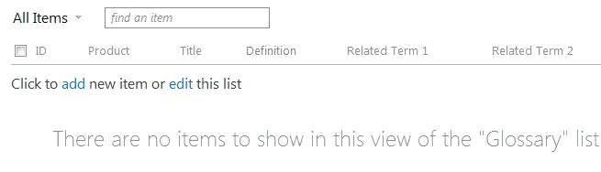

* + - All Items View

1. Disable Attachments
   1. In the **List Tools** ribbon, click the **List tab**, and then click **List Settings**.
   2. In the **General** **Settings** section, click **Advanced** **Settings**.
   3. In the **Attachments** section, select **Disabled**, and then click **OK**.
   4. Click **OK** for the Message from webpage dialog that opens.

## Task 2 – Import List Data

In this task, you will import data into the list from an Excel spreadsheet using Microsoft Access.

* Begin this task logged on to **SP as CONTOSO\Administrator**.

1. Import Data.
   1. **Navigate** to the default view of the Glossary list.
   2. In the **List Tools** ribbon, click the **List** tab.
   3. Click **Open with Access**.
   4. Confirm that **Link to data on the SharePoint** site is selected, and then click **OK**.
   5. Once the list is open in Access, on the **External Data** tab, in the **Import & Link** group, click **Excel**.
   6. In the **Get External Data - Excel Spreadsheet** dialog box, click **Browse**.
   7. Locatethe **Terms.xlsx** worksheet, and click **Open**.
   8. Select **Append a copy of the records to the table**, ensure that Glossary is selected in the drop-down list, and then click **OK**.
   9. In the **Import Spreadsheet Wizard**, click **Next**, then click **Next** again. Now click **Finish**.
   10. In the **Save Import Steps** dialog, click **Close**.
   11. **Open** the **Glossary** table in **Access**, and confirm that the data was imported.
   12. **Refresh** the **Glossary** list page in the browser, and confirm that the glossary data was imported to the list.
   13. **Close** Access.
2. Perform a Full Crawl.
   1. Open **SharePoint 2013 Central Administration**.
   2. On the Central Administration home page, under Application Management, click **Manage Service Applications**.
   3. On the **Service Applications** page, in the list of service applications, click **Search Service Application**.
   4. On the **Search Administration** page, in the left navigation pane, under Crawling, click **Index Reset**.
   5. On the **Index Reset** page, verify that the **Deactivate search alerts during reset** check box is checked, and then click **Reset Now**.
   6. In the confirmation dialog box that appears, click **OK** to confirm the content index reset.
   7. On the Search Administration page, in the left navigation pane, under Crawling, click **Content Sources**.
   8. On the Manage Content Sources page, point to the Local SharePoint sites content source, click the arrow that appears, and then click **Start Full Crawl**.

Note: Wait for the Full Crawl to complete before proceeding

1. Verify Metadata Properties.
   1. In the **Search Service Application**, click **Search Schema**.
   2. In the Managed Property filter, type **ows** and click the **Apply** button.
   3. Look in the filtered results and verify the following managed properties are defined, which correspond to the columns in the Glossary list.

* DefinitionOWSMTEXT
* ProductOWSTEXT
* RelatedTerm1OWSTEXT
* RelatedTerm2OWSTEXT

1. Test Search
   1. **Navigate** to the Search Center site.
   2. In the keyword box, enter **Argument** and click **Search**.
   3. Verify that search results are returned from the Glossary list.
2. Create a Managed Property
   1. Open **SharePoint 2013 Central Administration**.
   2. On the Central Administration home page, under Application Management, click **Manage Service Applications**.
   3. On the **Service Applications** page, in the list of service applications, click **Search Service Application**.
   4. Click **Search Schema**, then click **New Managed Property**.
      1. Property Name: **Product**
      2. Type: **Text**
      3. Searchable: **Checked**
      4. Queryable: **Checked**
      5. Retrievable: **Checked**
      6. Refinable: **Yes – active**
      7. Sortable: **Yes – active**
      8. Token Normalization: **Checked**
      9. Add a mapping – **ows_q_TEXT_Product**
3. Perform a **Full Crawl**.
   1. On the Search Administration page, in the left navigation pane, under Crawling, click **Content Sources**.
   2. On the Manage Content Sources page, point to the Local SharePoint sites content source, click the arrow that appears, and then click **Start Full Crawl**.

Note: Wait for the Full Crawl to complete before proceeding

1. Verify the managed property is functioning.
   1. Navigate to the Enterprise Search Center at <http://intranet.contoso.com/sites/search>.
   2. Enter the following search text: **Product:Word,** verify that search results are returned.

# Exercise 2: Creating the Search UI

In this next set of tasks, you create the user interface (UI) for the glossary search vertical. This interface will consist of a separate view dedicated solely to Glossary search results as well as a “block” view within the main search results experience. In practice, you can choose to implement one, the other, or both views in a solution.

## Task 1 – Create a Search Page

In this task, you will create a page for displaying Glossary search results.

* Begin this task logged on to **SP as CONTOSO\Administrator**.

1. Create a Page.
   1. Open the **Search Center**.
   2. Click the **Site** menu, and then click **View Site Contents**.
   3. Click **Pages**.
   4. In the **Library Tools** ribbon, click the **Files** tab, and then click **New Document**.
   5. Type **Glossary** in the title box, type **glossaryresults** in the URL Name box, select **(Welcome Page) Search Results** for Page Layout, and then click **Create**.
   6. Click the link for the **glossaryresults.aspx** page.
   7. On the glossaryresults.aspx page, click the **Check It In** link.
   8. Click the **Publish It** link to publish the page.
2. Connecting to Search Navigation.
   1. In the **Search Center**, click the **Site** menu, and then click **Site Settings**.
   2. Click **Search Settings** in the Search group.
   3. In the **Configure Search Navigation** section, click **Add link**.
   4. Type **Glossary** in the **Title** field.
   5. Click **Browse**.
   6. Click the **Pages** library and then the **glossaryresults.aspx** page.
   7. Click **Insert**.
   8. Click **OK**.
   9. Click **OK** again.

## Task 2 – Create a Result Source

In this task, you will create a Result Source for Glossary search results. The Result Source will then be filtered using a Query Transformation. This will allow the search vertical to show only results from the Glossary list. This is the equivalent of a scope in previous versions of SharePoint.

* Begin this task logged on to **SP as CONTOSO\Administrator**.

1. Create the Results Source.
   1. Open the **Search Center**.
   2. Click the **Site** menu, and then click **Site Settings**.
   3. Under **Search**, click **Result Sources**.
   4. On the **Manage Result Sources** page, click **New Result Source**.
   5. In the **Source Name** box, type **Glossary**.
   6. Ensure that the options **Local SharePoint Index**, **SharePoint Search Results**, and **Default Authentication** are selected.
   7. In the **Query Transformation** box, type the following query:  
      **{searchTerms} contentclass:STS_ListItem_GenericList AND path:http://intranet.contoso.com/sites/glossary/lists/glossary**

Note: The path element must correspond to the location of the Glossary list in your environment.

* 1. Click **Save**.

## Task 3 – Format Search Vertical Results

In this task, you will create a Result Type and template for displaying search results. The Result Type acts as a rule to determine when to apply special formatting to the search results. The special formatting is defined in an HTML template.

* You will need the file DefaultGlossary_Orig.html provided with the exercise.
* Begin this task logged on to **SP as CONTOSO\Administrator**.

1. Create the Display Template
   1. Open **DefaultGlossary_Orig.html** with **Microsoft Visual Studio**.
   2. In the HTML code, search for the following string:  
      <!--Paste code below this line-->
   3. Paste the following code immediately below the line:

<!-- Use the following line to cause the debugger to attach -->

<!--#_ debugger; _#-->

<div id="_#= $htmlEncode(itemId) =#_" name="Item" data-displaytemplate="DefaultItem" class="ms-srch-item" onmouseover="_#= ctx.currentItem_ShowHoverPanelCallback =#_" onmouseout="_#= ctx.currentItem_HideHoverPanelCallback =#_">

_#=ctx.RenderBody(ctx)=#_

<div id="_#= $htmlEncode(hoverId) =#_" class="ms-srch-hover-outerContainer"></div>

<!--#_ if(!$isNull(ctx.CurrentItem.Product)){ _#-->

<div><b>Product: _#=ctx.CurrentItem.Product=#_ </b></div>

<div>Related 1: _#=ctx.CurrentItem.RelatedTerm1OWSTEXT=#_ </div>

<div>Related 2: _#=ctx.CurrentItem.RelatedTerm2OWSTEXT=#_ </div>

<!--#_ } _#-->

</div>

* 1. **Save** the file as **DefaultGlossary.html**.

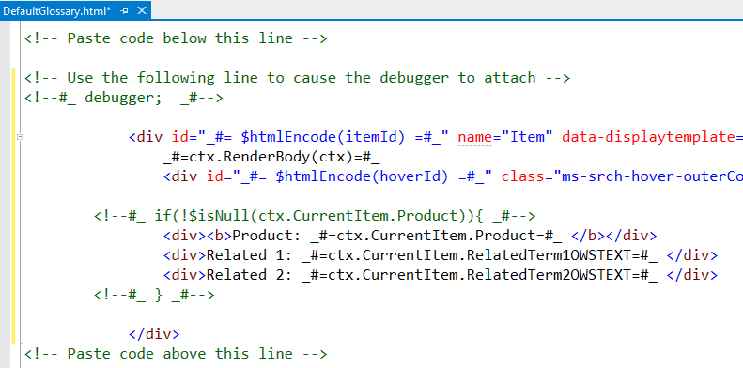

* + 1. Glossary Template

1. Upload the Display Template
   1. **Navigate** to the **Search Center**.
   2. Click the **Site** menu, and then click **Site Settings**.
   3. In the **Web Designer Galleries** section, click **Master Pages and Page layouts** to open the Master Page Gallery.
   4. Click **Display Template**s, and then click **Search**.
   5. Click the **Files tab** in the Library Tools ribbon, and then click **Upload Document**.
   6. Browse to locate the **DefaultGlossary.html** file, and then click **OK**.
   7. Click **Save**.
   8. Choose the **DefaultGlossary.html** file and choose **Publish a Major Version**.

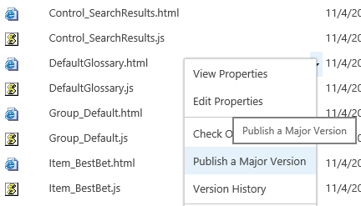

1. Create a Result Type
   1. **Navigate** to the **Search Center**.
   2. Click the **Site** menu, and then click **Site Settings**.
   3. Under **Search**, click **Result Types**.
   4. Click **New Result Type**.
   5. Type **Glossary Result** in the **Give It A Name** field.
   6. In the **Conditions** section, select **Glossary** in the **Which Source Should Results Match?** drop-down menu.
   7. In the **Actions** section, select **Default Glossary** in the **What Should These Results Look Like?** drop-down list.
   8. Click **OK**.

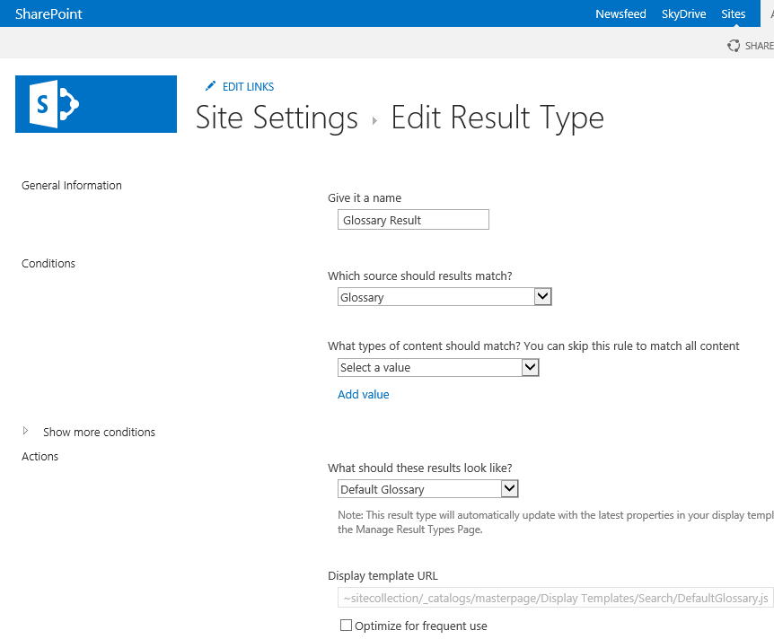

## Task 4 – Create a Query Rule

In this task, you will add a Results Block to show the Glossary results in a separate block from the main results.

* Begin this task logged on to **SP as CONTOSO\Administrator**.

1. Create a Glossary Rule
   1. Navigate to the **Search Center**.
   2. Click the **Site** menu, and then click **Site Settings**.
   3. Under **Search**, click **Query Rules** to open the Manage Query Rules page.
   4. Select **Local SharePoint Results** from the Select a Source drop-down.
   5. Click **Add** **Rule**.
   6. In the **Rule** **Name** box, type **Glossary** **Core**.
   7. In **Query Conditions**, click **Remove Condition** to remove the default condition.
   8. In the **Actions** section, click **Add Result Block**.
   9. Expand **Settings**.
   10. Select **This Block is Always Shown Above Core Results**.
   11. Select **Glossary** from the **Search This Source** drop-down list.

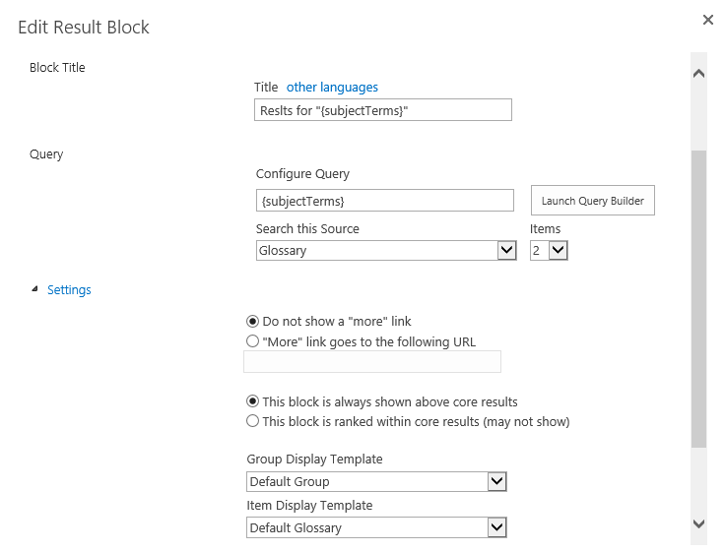

* 1. Click **OK**.
  2. Click **Change Ranked Results by Changing the Query**.
  3. In the select a query drop down, change the query to **Local SharePoint Results (System)**.
  4. In the query box, type the following query:  
     **{searchTerms} NOT (contentclass:sts_listitem_genericlist AND path: http://intranet.contoso.com/sites/glossary/lists/glossary)**

Note: The path element must correspond to the location of the Glossary list in your environment.

* 1. Click **OK**.
  2. Click **Save**.

## Task 5 – Format Search UI

* Begin this task logged on to **SP as CONTOSO\Administrator**.

1. Bind the Results Source to the Search Results web part
   1. **Navigate** to **glossaryresults.aspx**.
   2. Click the **Site** menu, and then click **Edit Page**.
   3. In the **Search Results** web part, select **Edit Web Part**.
   4. In the **Search Criteria** category, click **Change query**
   5. In the **Select Result Source** drop-down list, select **Glossary**.
   6. In the **Query text** area, type the following query:

**{searchboxquery}**

Note: The path element must correspond to the location of the Glossary list in your environment.

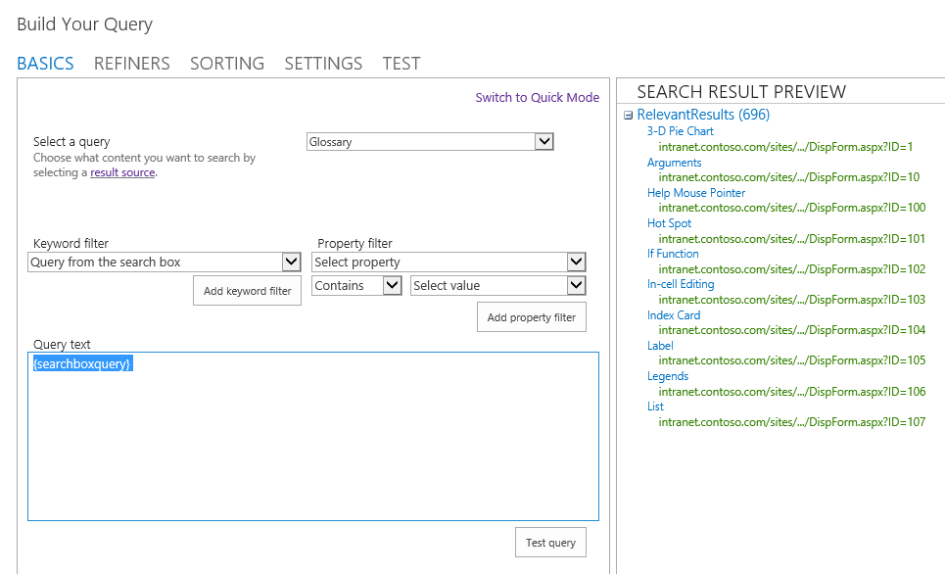

* + - Bind Result Source to Search Results web part
  1. Click **OK**

1. Under **Display Templates**, choose **Use a single display template to display items** and change the drop down to **Default Glossary**.

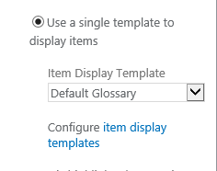

1. Click **OK** (make sure to do this or results will not be formatted correctly).
2. After saving changes to the web part, publish the page.
   1. On the yellow bar at the top of the page, click **Check it in**. Click **Continue**.
   2. Click **Publish this draft**.

## Task 6 – Test the Search Vertical

In this task, you will test the search vertical in SharePoint.

* Begin this task logged on to **SP as CONTOSO\Administrator**.

1. Testing.
   1. **Navigate** to **http://intranet.contoso.com/sites/search**.
   2. Click on the Glossary tab. In the keyword query box, type **Tab**.

* Note that if you left the line in the display template that includes “debugger;”, you will be prompted to launch the debugger for each rendered result. To avoid this behavior, edit the DefaultGlossary.html file and remove that line and upload the template again.
  1. Click **Search** and verify that you get results only from the Glossary List and that results are customized with our display template.

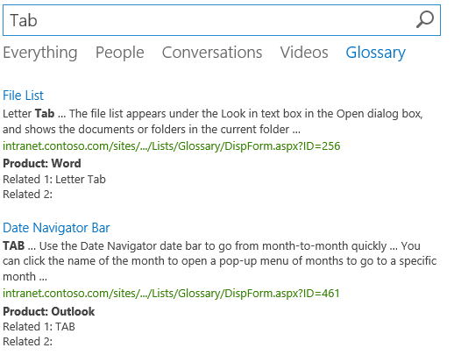

* 1. Click the **Everything** link on the page and verify that you get results from all sources, but that the Glossary results appear in a separate block.

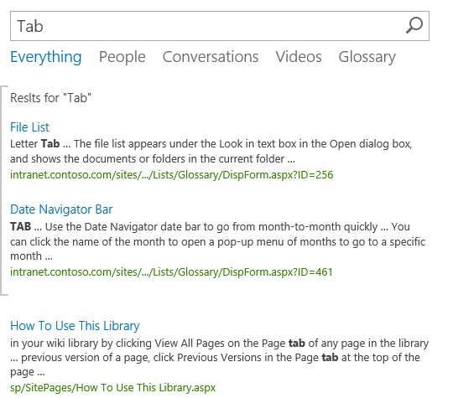

* + - Search Results

# Exercise 3: Search App

In this exercise, you will create a SharePoint App that uses search to display search results. This exercise will help you understand how to request permissions in an App for search and access services in the hosting farm.

## Task 1 – Create a New App

In this task, you will develop a new App in Visual Studio

* Begin this task logged on to **SP as CONTOSO\Administrator**.

1. Open Microsoft Visual Studio 2012 and create a new SharePoint App project
   1. Open **Microsoft Visual Studio 2012**
   2. Select **File⮚New Project** from the main menu
   3. Click the **Templates⮚Visual C#⮚Office/SharePoint⮚Apps** node and select the **App for SharePoint 2013** project template
   4. Name the new project **SearchApp**
   5. Click the **OK** button

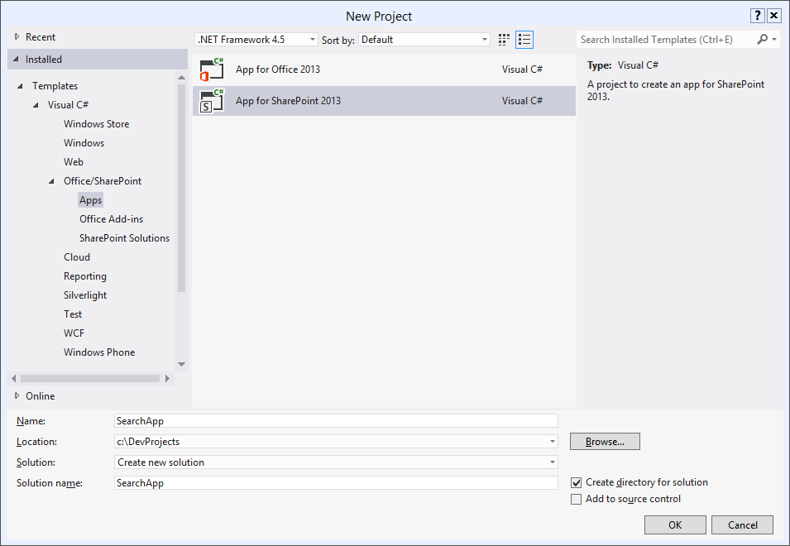

* + - Create new SharePoint App Project
  1. In the **New App for SharePoint Wizard**, name the new SharePoint App **Membership App**.
  2. Specify the site you will use for this lab.
  3. Select **SharePoint-hosted** as the hosting type.
  4. Click **Finish**.

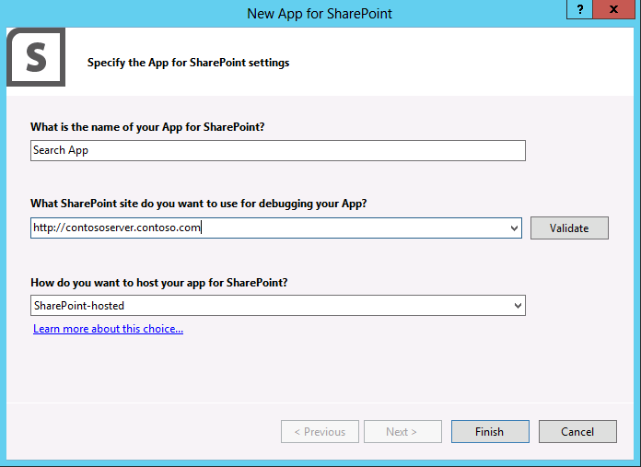

* + - New App for SharePoint

1. Code the App
   1. Open **Deafult.aspx** in Visual Studio for editing
   2. **Add** the following code within the **PlaceHolderMain** Content Placeholder control with the following:

<div id="toolbarDiv" style="display: none">

<input type="text" style="width: 200px" id="queryTerms" />

<input type="button" value="Search"

onclick="executeQuery($get('queryTerms').value);" />

</div>

<div id="resultsDiv"></div>

* 1. **Open** **App.js** for editing.
  2. **Add** the following code to **App.js** to issue a search query:

$(document).ready(function () {

var e = ExecuteOrDelayUntilScriptLoaded(

showToolbar,

"sp.js");

});

function showToolbar() {

$("#toolbarDiv").show();

}

function executeQuery(queryTerms) {

Results = {

element: '',

url: '',

init: function (element) {

Results.element = element;

Results.url = _spPageContextInfo.webAbsoluteUrl +

"/_api/search/query?querytext='" + queryTerms + "'";

},

load: function () {

$.ajax(

{

url: Results.url,

method: "GET",

headers: {

"accept": "application/json;odata=verbose",

},

success: Results.onSuccess,

error: Results.onError

}

);

},

onSuccess: function (data) {

var results =

data.d.query.PrimaryQueryResult.RelevantResults.Table.Rows.results;

var html = "<table>";

for (var i = 0; i < results.length; i++) {

html += "<tr><td>";

html += results[i].Cells.results[3].Value;

html += "</td><td>"

html += results[i].Cells.results[6].Value;

html += "</td><tr>";

}

html += "</table>";

Results.element.html(html);

},

onError: function (err) {

alert(JSON.stringify(err));

}

}

Results.init($('#resultsDiv'));

Results.load();

}

* 1. Open the **AppManifest.xml** designer.
  2. In the **Permission Requests** box, select **Search** from the Scope drop-down.
  3. Select **QueryAsUserIgnoreAppPrincipal** from the **Permission** drop-down.

## Task 2 – Deploy the App

In this task, you will run the App and see it hosted in SharePoint.

* Begin this task logged on to **SP as CONTOSO\Administrator**.

1. Deploy the App
   1. Select **Build⮚Deploy Solution** in Visual Studio.
   2. When prompted by SharePoint to grant permissions, click **Trust It**.

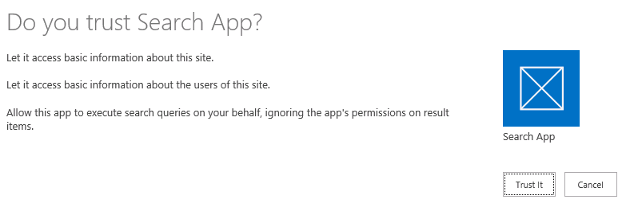

* + - Grant the App Permission
  1. Launch the Search App.
  2. You should now see a text box and button. Try entering a search term and clicking the button. Results should subsequently appear in the App.

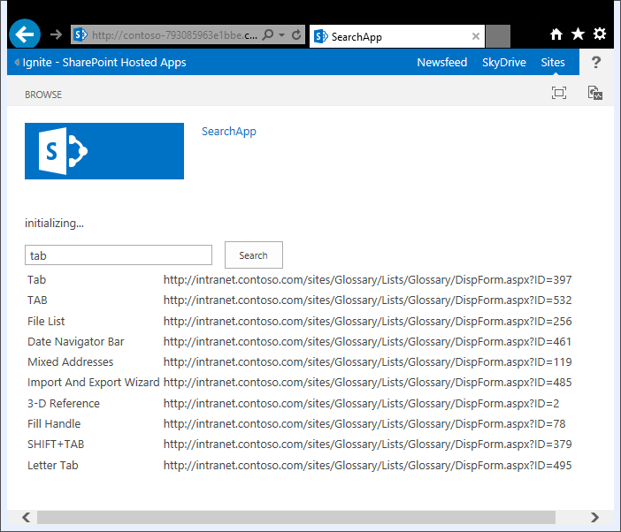

* + - Search Results